**MAHARANA PRATAP COLLEGE OF ENGINEERING**

**COMPUTER SCIENCE**

**MINI PROJECT**

ON

**BLOCKCHAIN TECHNOLOGY**

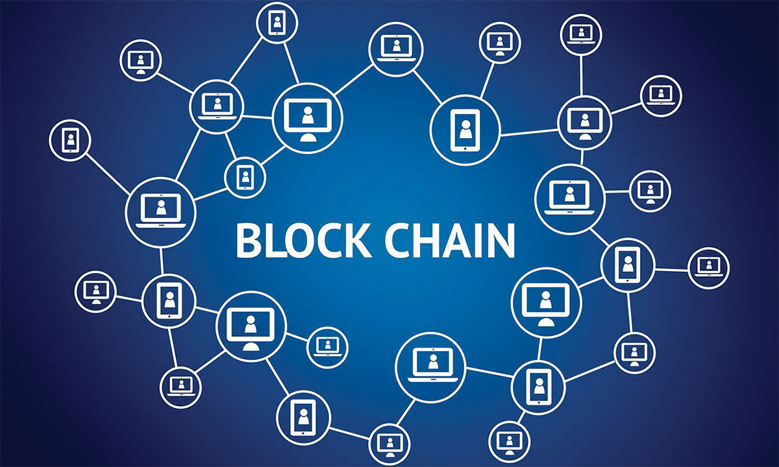

**Submitted By:**

**Shruti Omer**

**1852210036(A3)**

**Submitted To:**

**Mr Prasoon Tripathi**

**What is Blockchain?**

A blockchain is digitized, distributed, consensus based secure storage of information protected from revision and tampering over the peer to peer network.

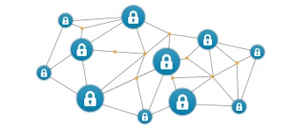

More specifically,

* It is a digitized store for information in the form of transactions.
* It is distributed, this nobody controls it.
* Consensus algorithms make sure of its security and immutability
* When a new block is added to the blockchain, it is linked to the previous block using a cryptographic hash.
* Data gets stored in chronological order.
* Everyone present over the network can view the transactions.

**History of the Blockchain**

**2008**: Satoshi Nakamoto, a pseudonym for a person or group, publishes “[Bitcoin: A Peer to Peer Electronic Cash System](https://bitcoin.org/bitcoin.pdf" \t "_blank)."

**2009**: The first successful Bitcoin (BTC) transaction occurs between computer scientist Hal Finney and the mysterious Satoshi Nakamoto.

**2010**: Florida-based programmer Laszlo Hanycez completes the first ever purchase using Bitcoin — two Papa John’s pizzas.

**2013**: BTC market cap surpassed $1 billion.Bitcoin reached $100/BTC for first time.Buterin publishes “[Ethereum Project](https://github.com/ethereum/wiki/wiki/White-Paper" \t "_blank)" paper suggesting that blockchain has other possibilities besides Bitcoin (e.g., smart contracts).

**2014**: Gaming company Zynga, The D Las Vegas Hotel and Overstock.com all start accepting Bitcoin as payment.PayPal announces Bitcoin integration.

**2015:** Number of merchants accepting BTC exceeds 100,000.

**2016**: Tech giant IBM announces a blockchain strategy for cloud-based business solutions. Government of

Japan recognizes the legitimacy of blockchain and cryptocurrencies.

### 2017: Bitcoin reaches $1,000/BTC for first time. Cryptocurrency market cap reaches $150 billion. Dubai announces its government will be blockchain-powered by 2020.

### 2018: Facebook commits to starting a blockchain group and also hints at the possibility of creating its own cryptocurrency. IBM develops a blockchain-based banking platform with large banks like Citi and Barclays signing on.

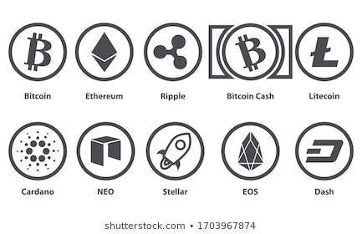

**Blockchain v/s Traditional Database**

A key property of blockchain technology, which distinguishes it from traditional database technology, is public verifiability and decentralization, which is enabled by integrity and transparency.

|  |  |  |
| --- | --- | --- |
| **Characteristic** | **Blockchain** | **Database** |
| **Authority** | Decentralized | Centralized |
| **architecture** | Distributed | Client Server Architecture |
| **Data Handling** | Only Read and Write | CRUD (create, read, update, delete)  operations |
| **Integrity** | Nobody can change | Alterations are allowed |
| **Transparency** | Built in | Not Transparent |
| **Trust** | Algorithms | Owner of the Database or Administrator |

**Comparison between Current Banking System and Banking System using Blockchain**

1. **Decentralised Trust**

The primary advantage of blockchain is its method of verifying and tracking transactions—it enables individuals and organisations to process transactions without the need for a third party or a central bank. Instead of everything being controlled by a single central authority.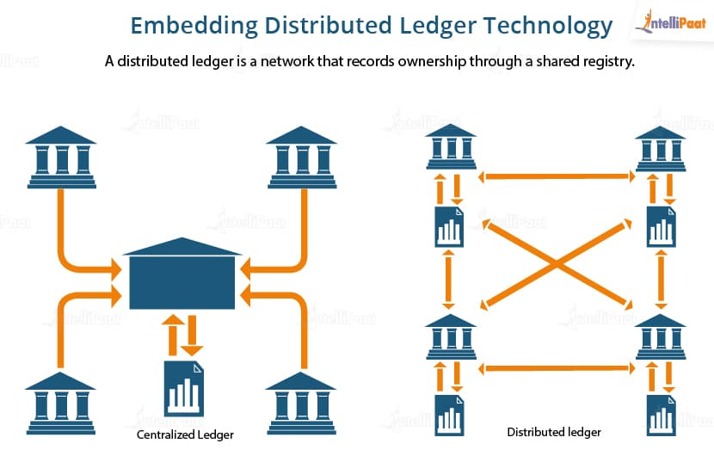

1. **Enhanced Security**

Once data is recorded in a block, it cannot be altered retroactively—this makes blockchain inherently secure. Since it is shared among a large number of users, it is difficult to shut down or hack, and can be viewed by anyone using the system, ensuring transparency. This reduces the risk of fraud.

1. **Decreased Costs**

By leveraging the distributed ledger approach to form a system that decentralises trust, banks are able to decrease transaction fees significantly by eliminating third party intermediaries and overhead costs for exchanging assets.

1. **Increased Efficiency**

Blockchain eliminates the risk of errors and duplication, and is consequently ideal for refurbishing a range of digital processes. It also enables transactions to be processed 24/7. As blockchain helps banks to store data in blocks using a tamper-proof format. Blockchain data is complete, accurate, and reliable. Additionally, adding all transactions to a single, publically available ledger eliminates the disorder and complexity associated with multiple ledgers.

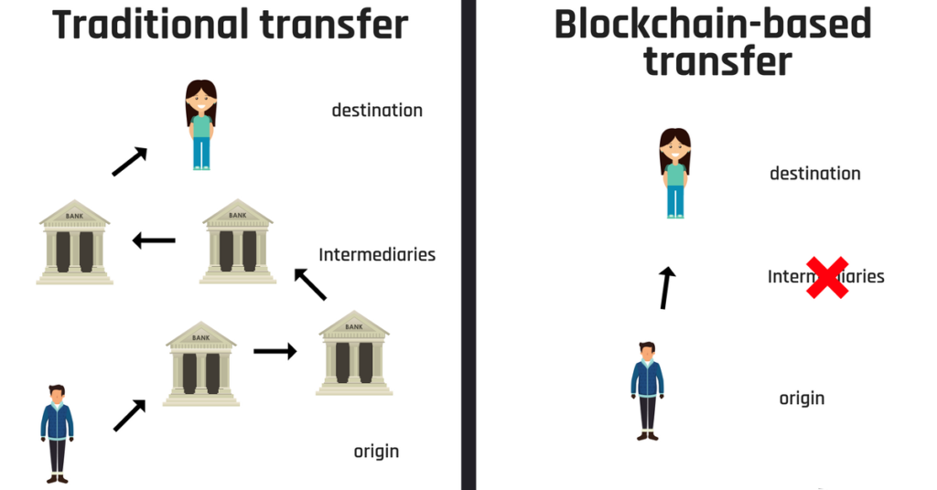

**How Blockchain works?**

Blockchain consists of three important concepts:

* Blocks
* Nodes
* Miners.

**Blocks**

Every chain consists of multiple blocks and each block has three basic elements:

* The **data** in the block.
* A 32-bit whole number called a **nonce.** The nonce is randomly generated when a block is created, which then generates a block header hash.
* The **hash** is a 256-bit number wedded to the nonce. It must start with a huge number of zeroes (i.e., be extremely small).

When the first block of a chain is created, a nonce generates the cryptographic hash. The data in the block is considered signed and forever tied to the nonce and hash unless it is mined.

### Miners

Miners create new blocks on the chain through a process called mining.In a blockchain every block has its own unique nonce and hash, but also references the hash of the previous block in the chain.

Miners use special software to solve the incredibly complex math problem of finding a nonce that generates an accepted hash. Because the nonce is only 32 bits and the hash is 256, there are roughly four billion possible nonce-hash combinations that must be mined before the right one is found. When that happens miners are said to have found the "golden nonce" and their block is added to the chain.

Making a change to any block earlier in the chain requires re-mining not just the block with the change, but all of the blocks that come after. This is why it's extremely difficult to manipulate blockchain technology

When a block is successfully mined, the change is accepted by all of the nodes on the network and the miner is rewarded financially.

**Nodes**

One of the most important concepts in blockchain technology is decentralization. No one computer or organization can own the chain. Instead, it is a distributed ledger via the nodes connected to the chain. Nodes can be any kind of electronic device that maintains copies of the blockchain and keeps the network functioning. Every node has its own copy of the blockchain and the network must algorithmically approve any newly mined block for the chain to be updated, trusted and verified. Since blockchains are transparent, every action in the ledger can be easily checked and viewed. Each participant is given a [unique alphanumeric identification number](https://hbr.org/2017/01/the-truth-about-blockchain) that shows their transactions.

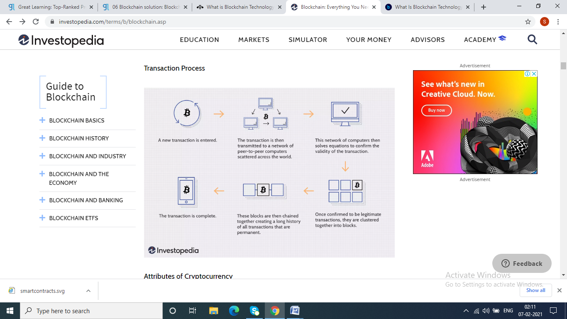

**Applications of Blockchain Technology**

* Secure sharing of medical data

E.g. BursTIQ big data Blockchain

* Music royalties tracking

E.g.Mediachain

* Cross-border payments
* Real-time IoT operating systems

E.g. Filament

* Personal identity security

E.g. Civic

* Anti-money laundering tracking system
* Supply chain and logistics monitoring

E.g. Block Array

* Voting mechanism

E.g. Voatz

* Advertising insights

E.g. MadHive

* Original content creation
* Cryptocurrency exchange
* Real estate processing platform

E.g. Propy